¡Día de Independencia de Panamá!
Since Panama was claimed by Spain in 1501, it was part of Spain for 300 years. Though, Panama joined Colombia in 1821. They were eventually their own country in 1903. The date of independence from Spain was celebrated on November 28th, though the independence from Colombia was celebrated on November 3rd. to add to these official independence days, The First Call for Independence is celebrated on November 10th.

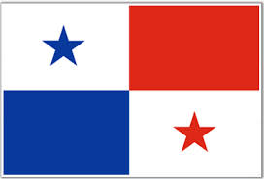

La celebracíon estas a la casa de José y Maria. Nosotros nos celebramos en Lunes, 10 de Noviembre, 2014. Yo tengo la cumida y las bebidas, no necesario llevar nada. ¡Tú necesita sólo a ti mismo! ¡Nos vemos allí!

